# Exercise: Wireframing the project

## ****Overview****

In this exercise, you will create a wireframe of the homepage of the Little Lemon website. On completion, you will have all the skills to wireframe your design solution for your project on the reserve-a-table section of the Little Lemon website.

A wireframe is like an architect's drawing - a building blueprint but for a digital product. Its purpose is to create a basic structure for each screen in the design before things like branding, colors and images are considered. In other words, wireframes provide a way to communicate ideas quickly that can be refined later. With wireframes, the focus is placed on the user experience and what users need to accomplish a task.

Although wireframes can be sketched out on paper, in this exercise, Figma will be used to draw the wireframe. This makes it possible to share the wireframe with other team members, giving them the opportunity to make comments in the same document.

## ****Scenario****

Little Lemon has faced difficulties with the reserve-a-table feature on its website. The feature doesn’t exist in the navigation bar and there is no specific button on its homepage to highlight this option. In this exercise, you will create a wireframe of the homepage incorporating this feature.

## ****Instructions****

### ****Step 1: List the client's requirements****

First, let's list the Little Lemon owners’ (your client's) requirements. These will become content blocks that will provide a skeleton of where the content will appear in the wireframe:

* About Little Lemon
* Highlights and specials
* Descriptions and photos of dishes
* Navigation bar
* Footer
* Testimonials

Now, that you have a better idea of the content, let’s start creating the actual wireframe in Figma.

### ****Step 2: Create the frame and grid****

* Create a 1440 x 2900 frame
* Add a 12-column layout grid to the frame.

**Note:** You may wish to revisit the [Grids and constraints](https://www.coursera.org/learn/principles-of-ux-ui-design/lecture/5adcY/grids-and-constraints) lesson item in the **Principles of UX/UI** course before you begin or refer to it as you go along.

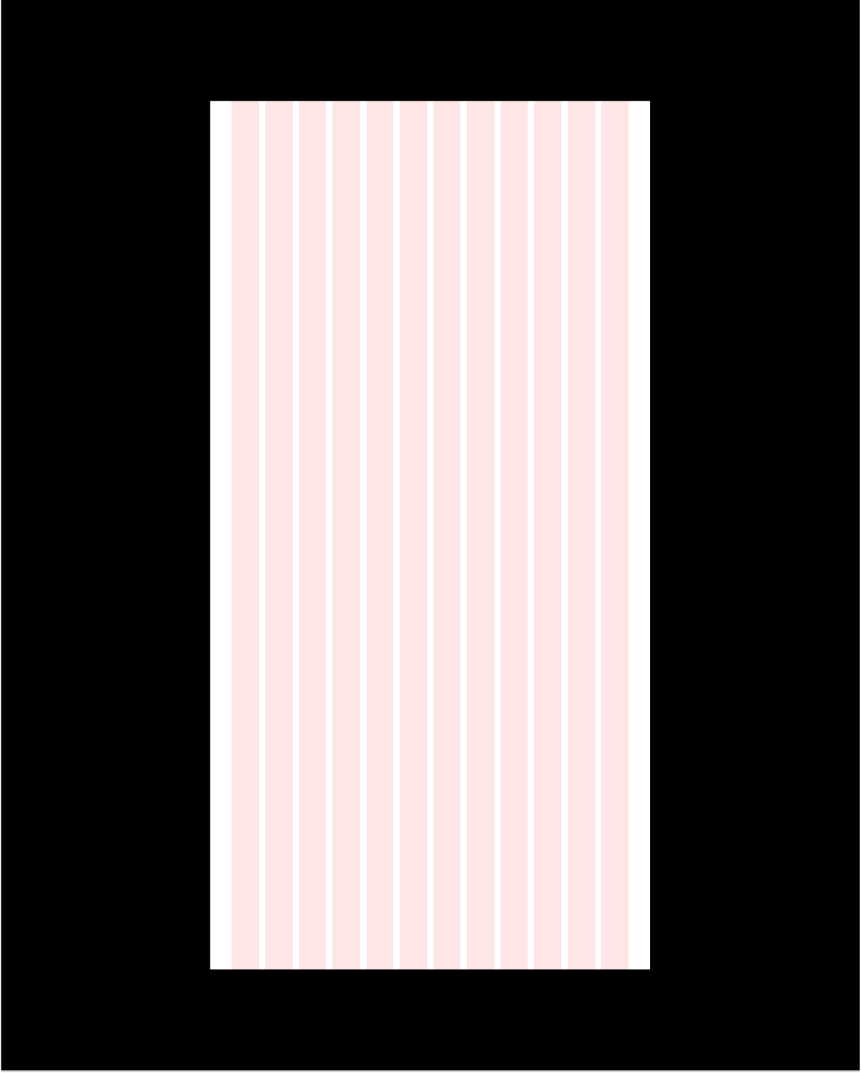

* Construct content blocks using rectangles and name the sections. In the first frame, you need content blocks that contain the following:
  + Navigation bar
  + Hero section that showcases the Little Lemon restaurant
  + Highlights section showing the week’s specials
  + Testimonials
  + About the Little Lemon restaurant
  + Footer

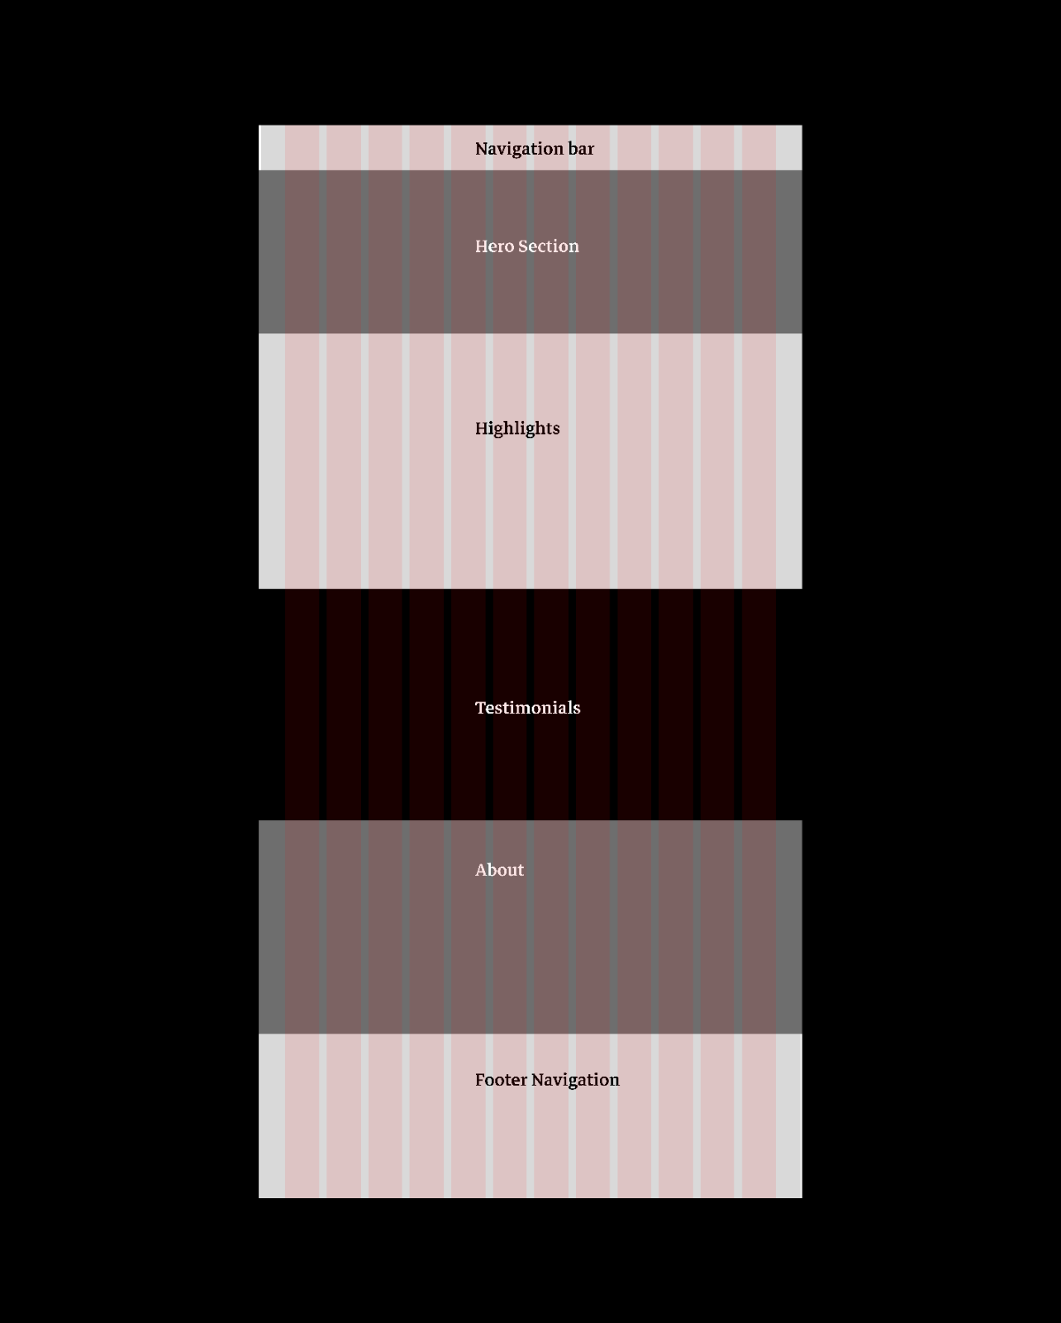

* Move the content blocks out of the frame.
* Select the rectangles and make them narrower to give you a rough guide of the content blocks to use as a reference when designing within the frame.

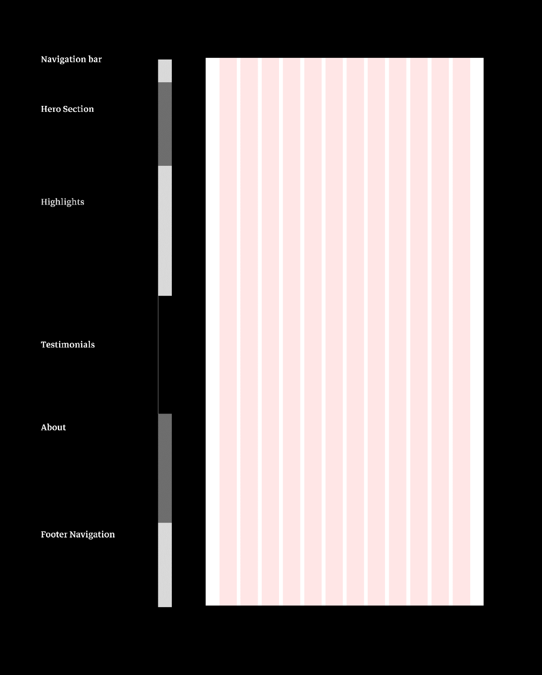

### ****Step 3: Design the Navigation Bar content block****

In the navigation bar, the elements you need are the Little Lemon logo and links to the other pages on the website.

* For the logo, create a rectangle and draw diagonal lines through it. This is a conventional way to denote a placeholder on a wireframe if an image is not readily available.
  + The Little Lemon owners have provided a list of pages needed for the website, as given below. You'll need to link to each one:
    - Home
    - About
    - Menu
    - Reservations
    - Order online
    - Login

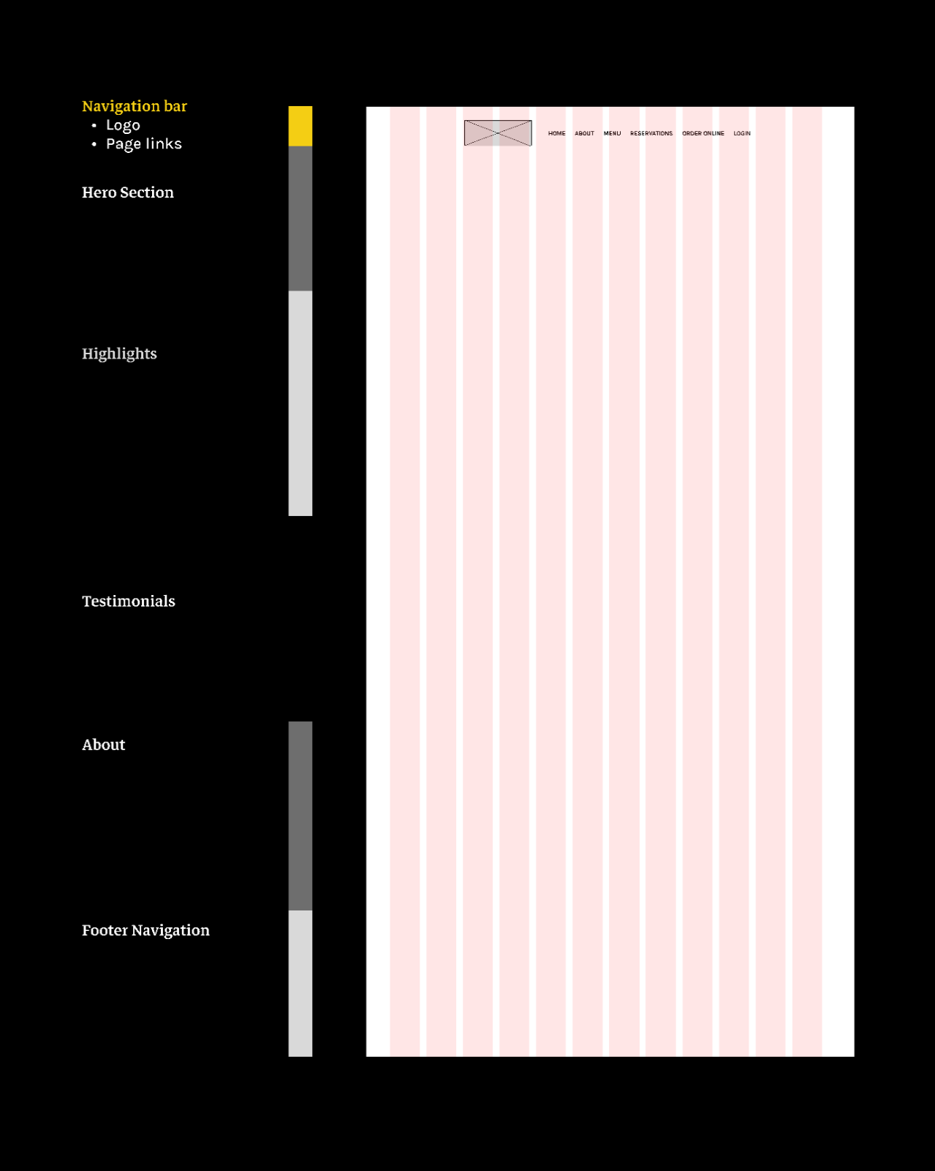

### ****Step 4: Design the Hero Section content block****

* In the Hero content block, include:
  + The Little Lemon name
  + Where it is located
  + A brief description of what type of food it offers
  + The option to book a table online
* In relation to the latter item, put this in the content block as a button, so that, once clicked, the user is brought to another page where they can carry this task out. To do this, add a grey background and populate the block.

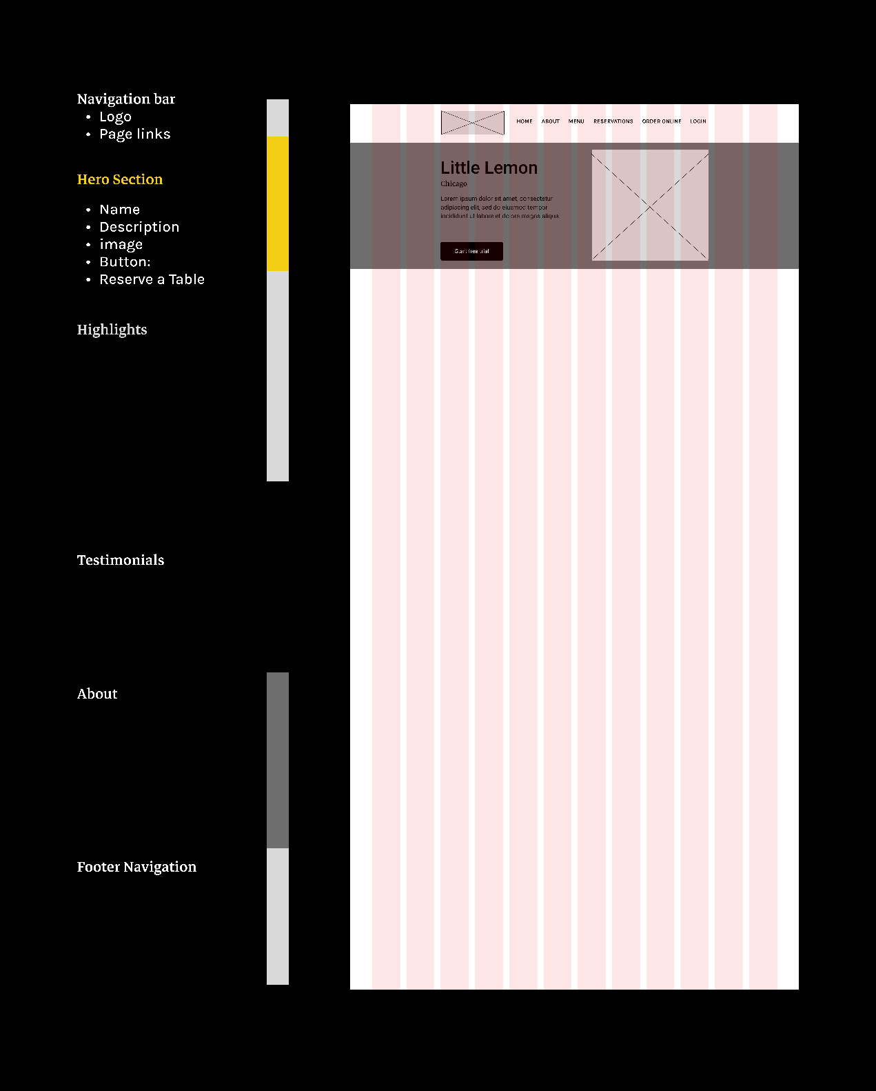

### ****Step 5: Design the Highlights content block****

It’s now time to move on to the Highlights block, where the owners want to highlight Little Lemon’s weekly specials.

* In this section, you should include the following:
* Title
* Name of the dish
* Dish description
* Price and
* Image of the dish
* Note that when a dish is clicked, the user is taken to another screen and that this highlights section is scrollable horizontally in order to see further items.
* Add a button so the user can go to the order online page.

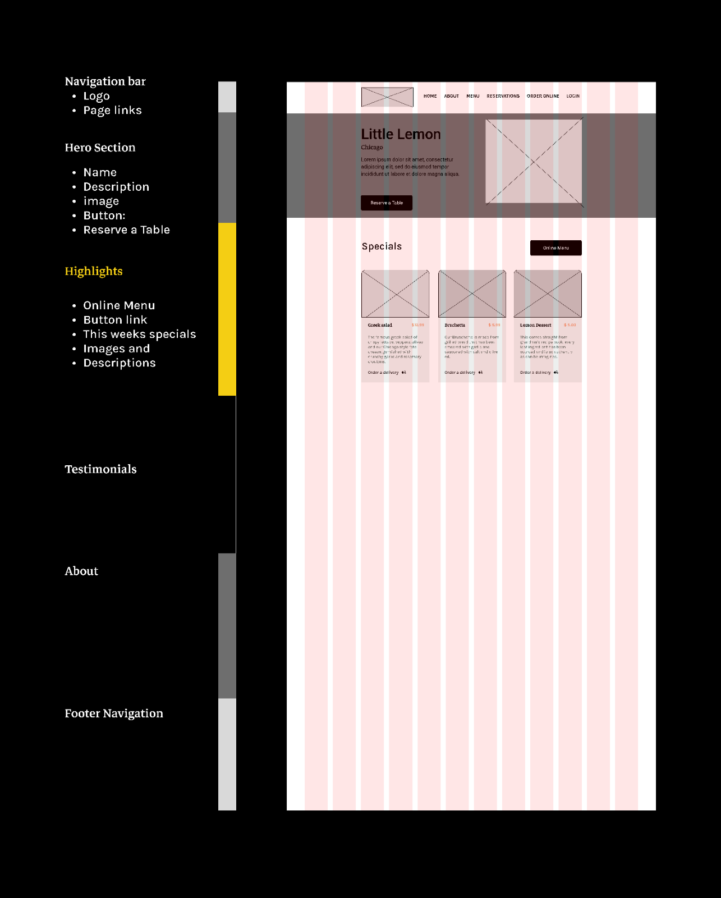

### ****Step 6: Design the Testimonials content block****

Once users have created a profile and logged in, they can leave reviews and ratings out of 5. To accomplish this:

* Add a background to separate it from the Highlights content block above.
* Create placeholders for the reviews.

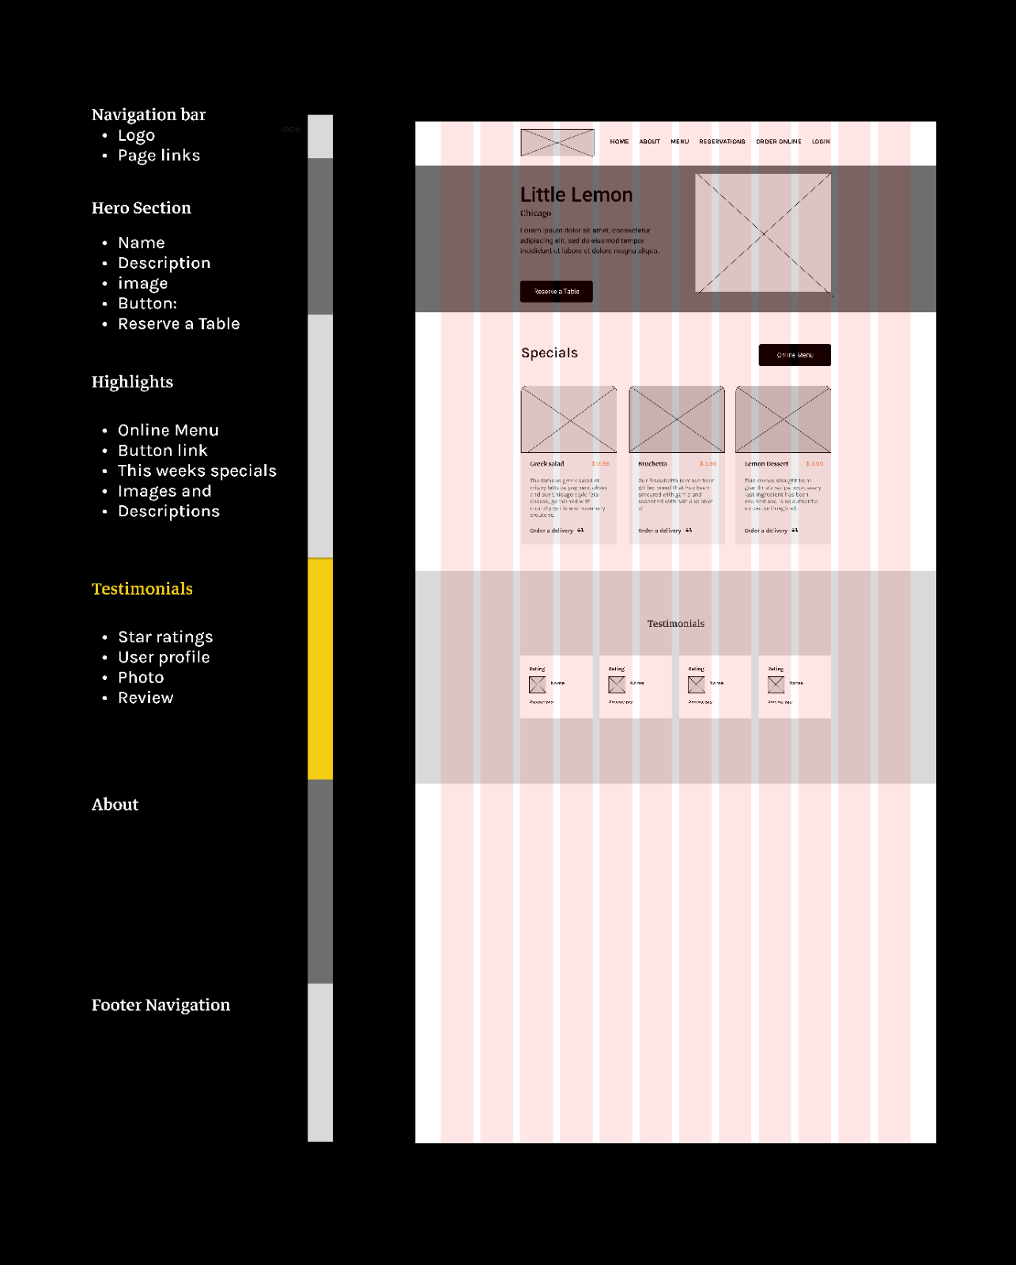

### ****Step 7: Design the About content block****

* As the Little Lemon owners have yet to provide the written content for this section, add a text box placeholder.
* Because you will need some images here, also add image placeholders.

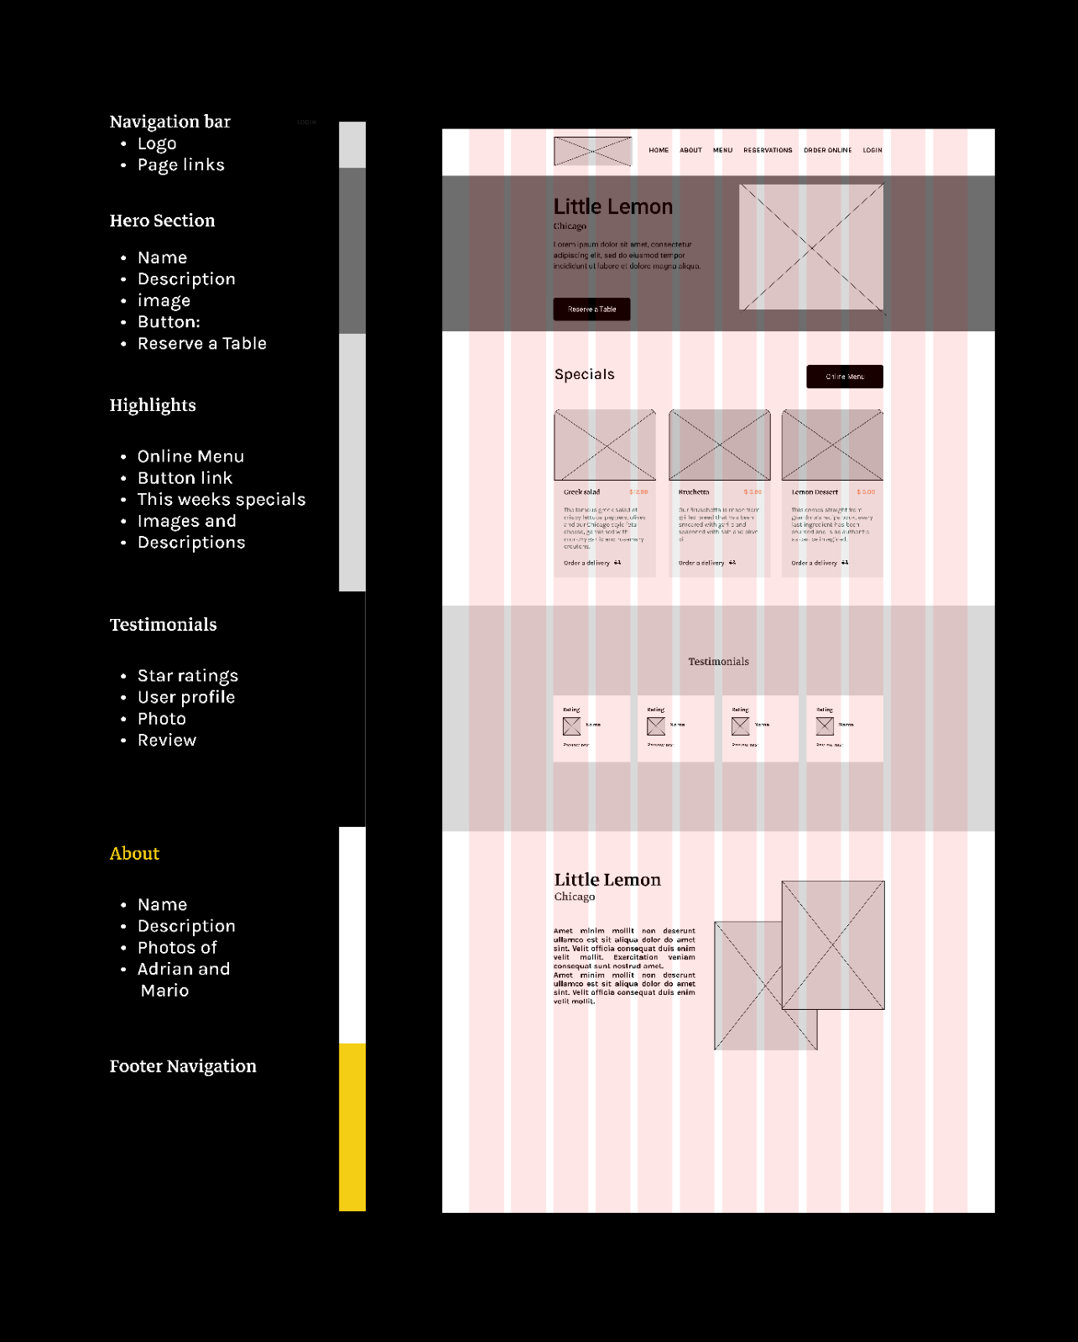

### ****Step 8: Design the Footer Navigation content block****

* First add a background, followed by the following content:
* Logo
* Doormat navigation (links to other pages)
* Contact details
* Social media links

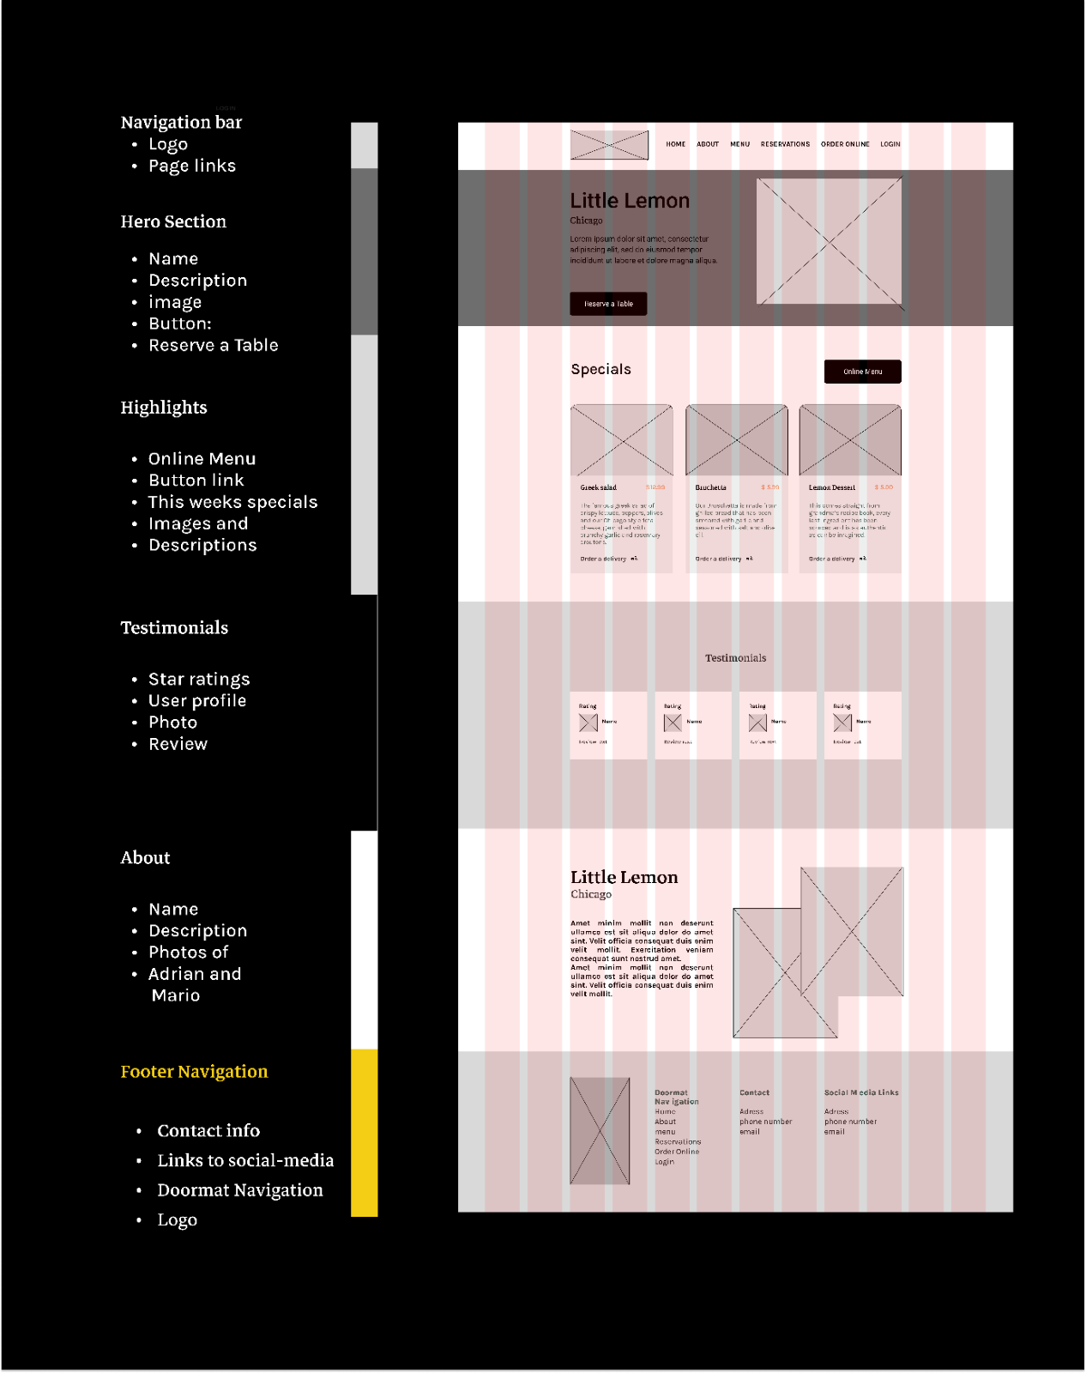

* Repeat this process for all the screens in the reserve-a-table page section of the website.

**Note:** No colors, fonts or images are included at this stage. All that is important when wireframing the project is the content, layout and functionality.

## ****Conclusion****

Now that you have covered the basics in wireframing and wireframed the first page or homepage, you can wireframe and design your solution for the reserve-a-table project.